|  |
| --- |
| TS059 - TC085_Process Recontract of Electric Service Case to Application Closed |

|  |
| --- |
| TC122_Recontract of Service via CXE Apply_Contractor; CAN with Multiple SIN |

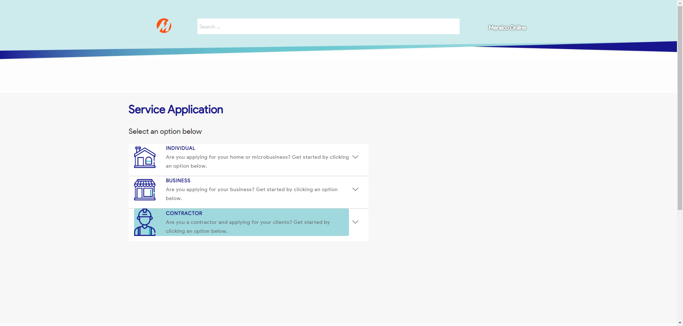

|  |
| --- |
| Step 2 - Click on Contractor |
| The following should be displayed under Contractor - Start Service - Modify Service - Reactivate Service - Stop Service |

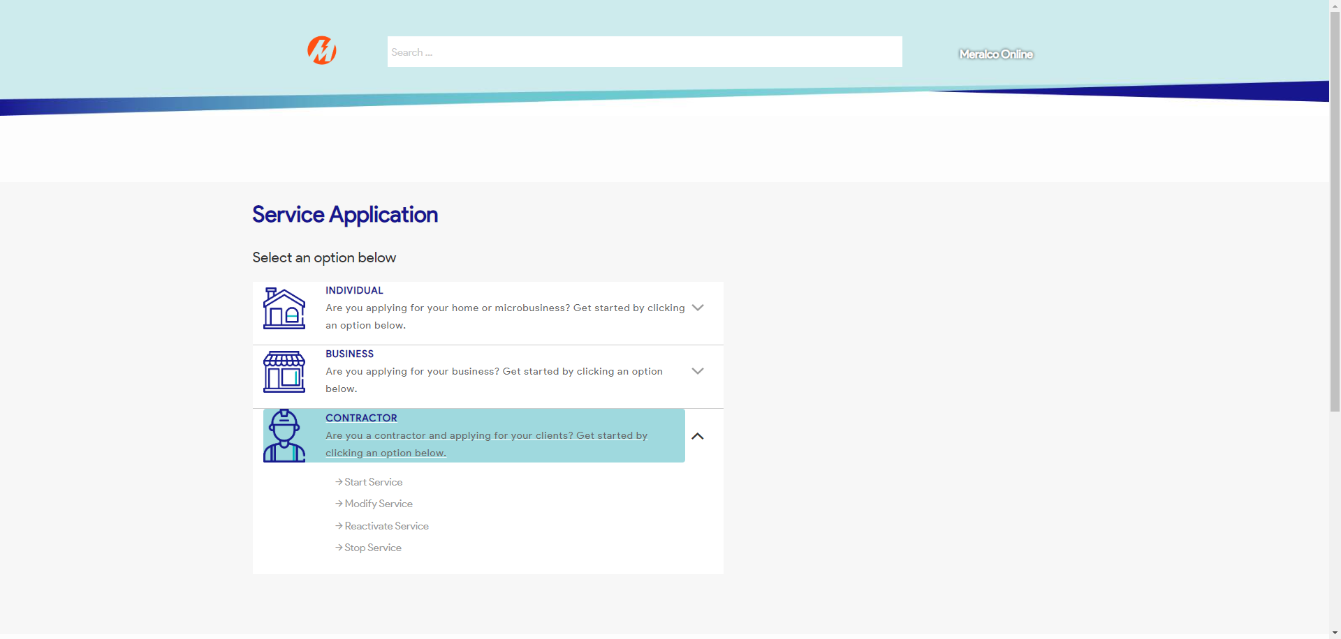

|  |
| --- |
| Step 3 - Click on Reactivate Service |
| Reactivate Service page should be displayed |

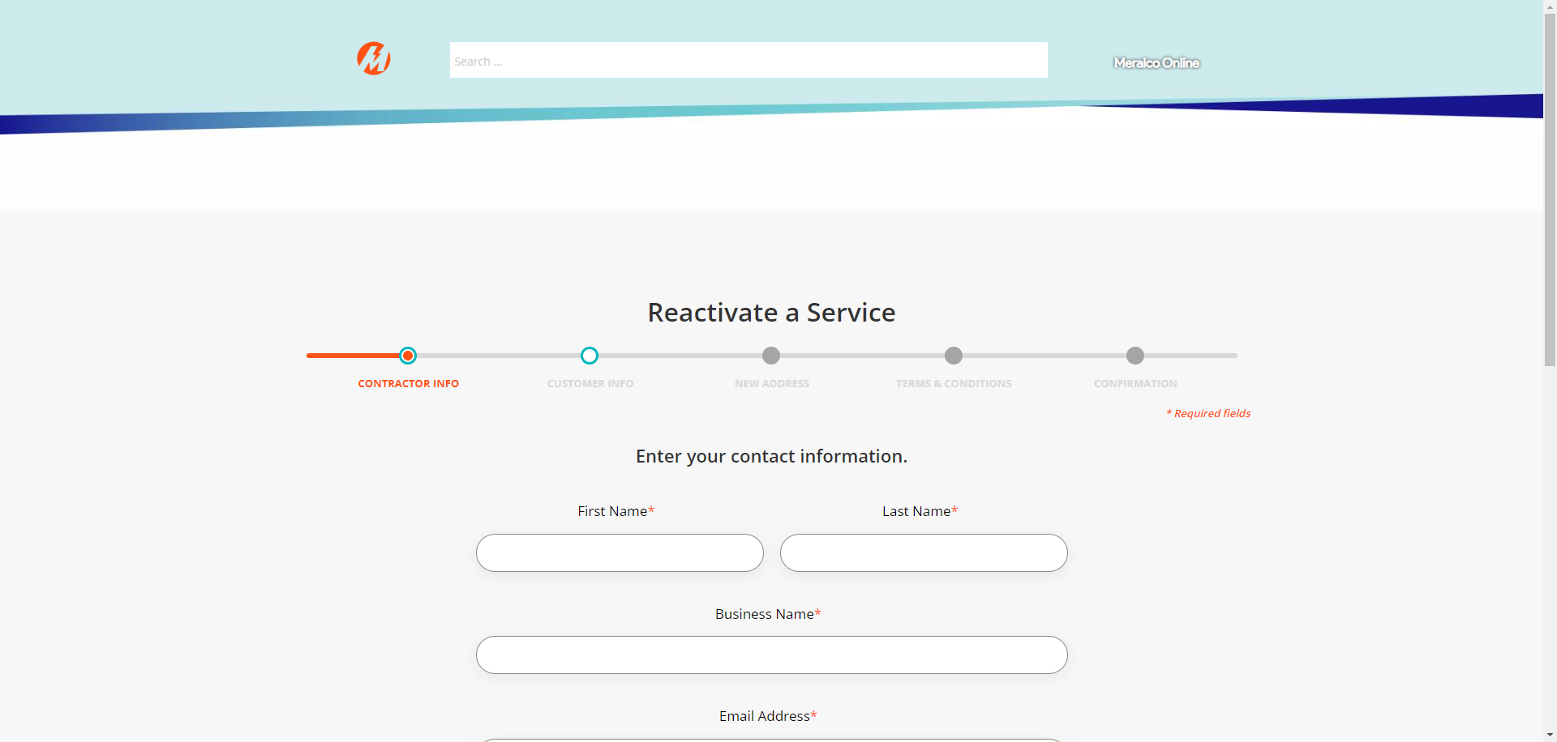

|  |
| --- |
| Step 4 - Populate the following: First Name* Last Name* Business Name* Email Address* Mobile Number* Relationship to Customer* >Click Next |
| Fields should be populated; Customer Info tab should be displayed |

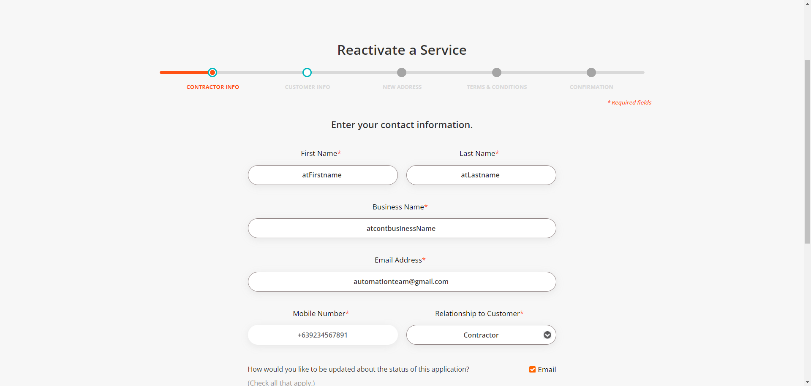

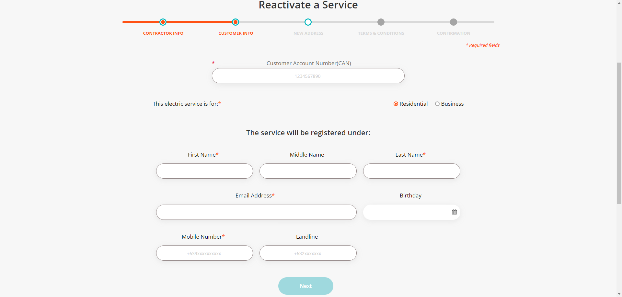

|  |
| --- |
| Step 5 - Validate if CAN field is visible and enabled |
| CAN field should be visible and enabled |



|  |
| --- |
| Step 6 - Populate Customer Account Number field |
| Customer Account Number field should be populated; Service ID Number field should be displayed |

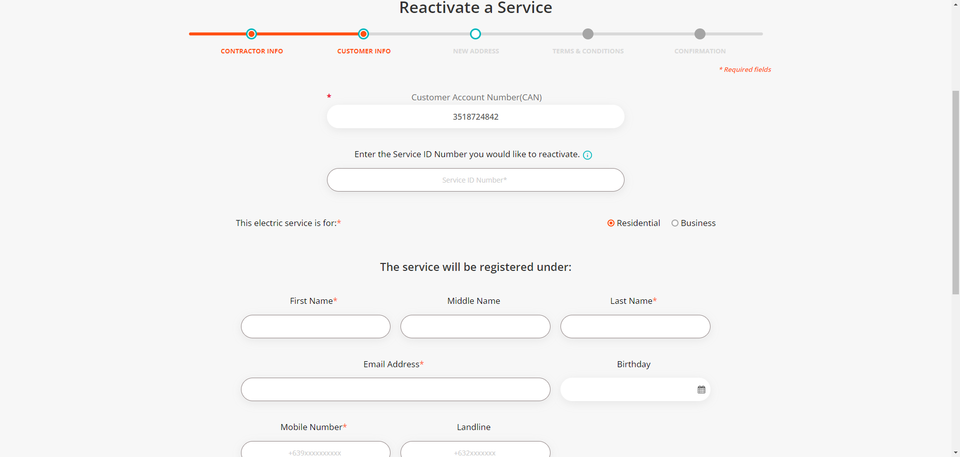

|  |
| --- |
| Step 7 - Populate Service ID Number |
| Service ID Number field should be populated |

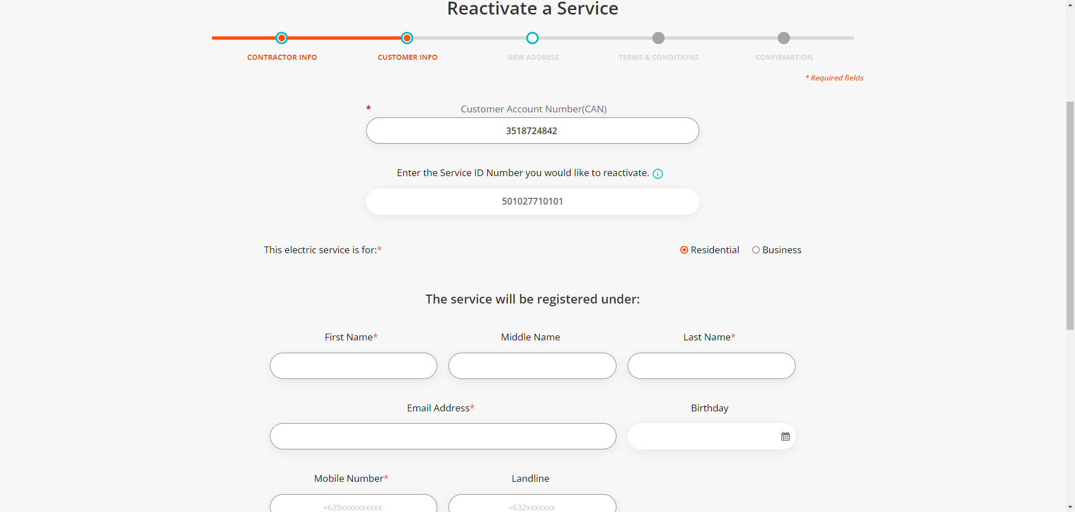

|  |
| --- |
| Step 8 - Populate the following field: First Name* Last Name* Email address* Mobile Number* Landline (optional) Birthday (optional) > Click Next |
| Fields should be populated; New Address tab should be displayed |

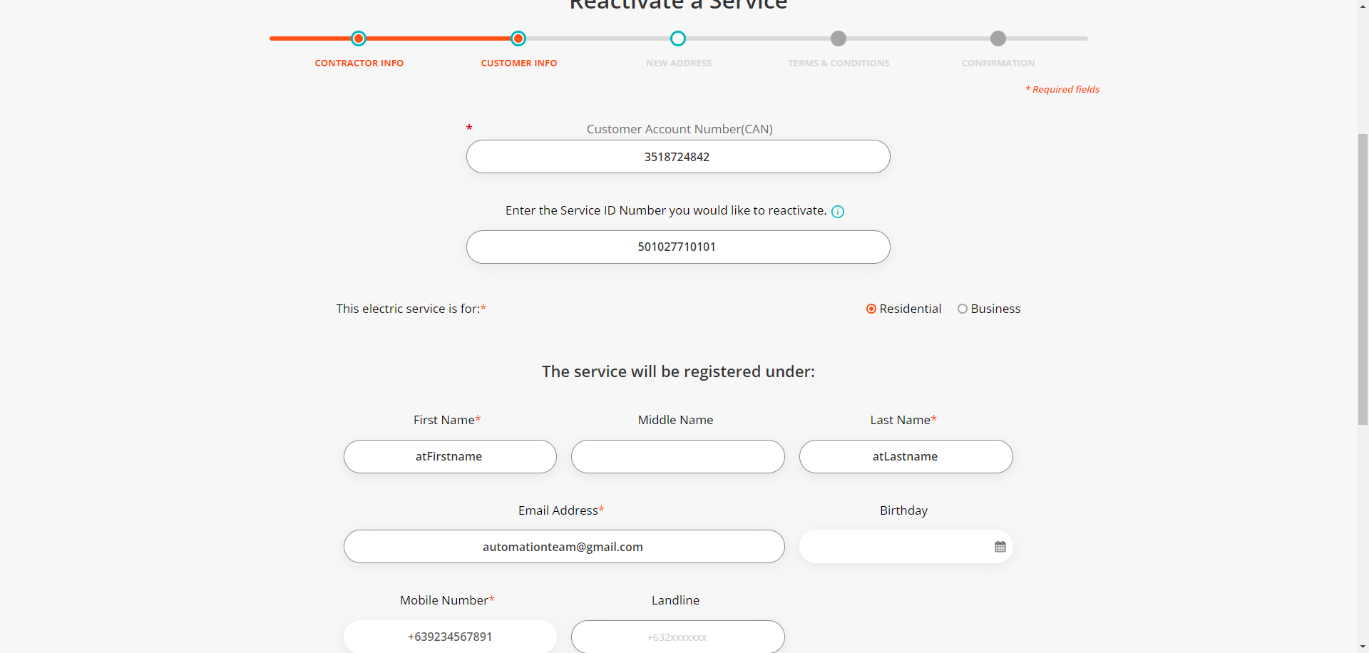

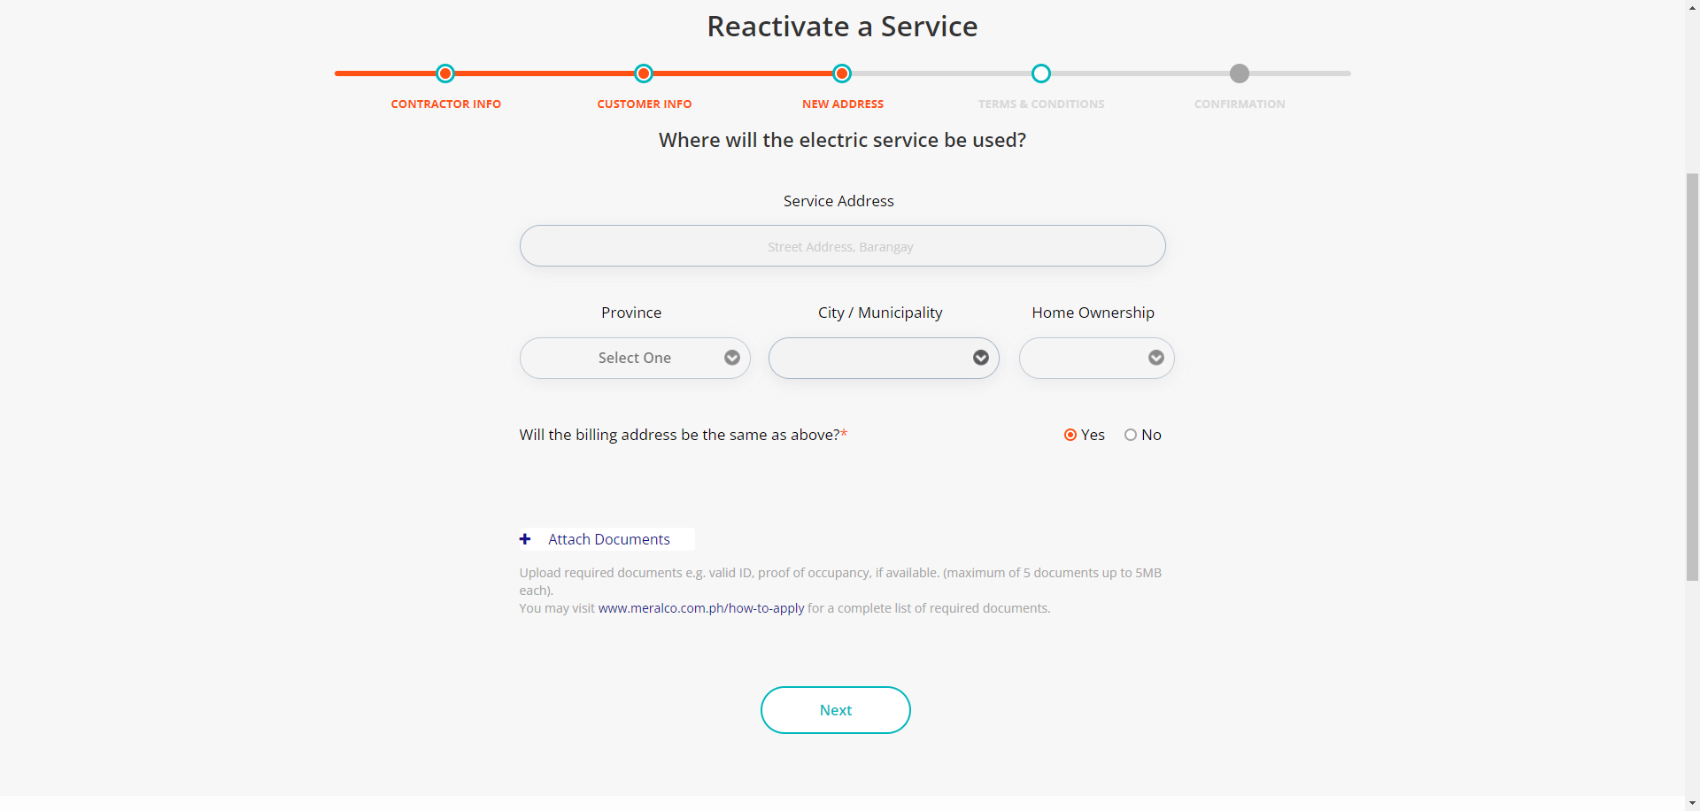

|  |
| --- |
| Step 9 - Populate the following: Service Address Province City / Municipality Home Ownership Billing Address indicator > Attach Documents > Click Next |
| Fields should be populated; Value Added Service tab should be displayed |

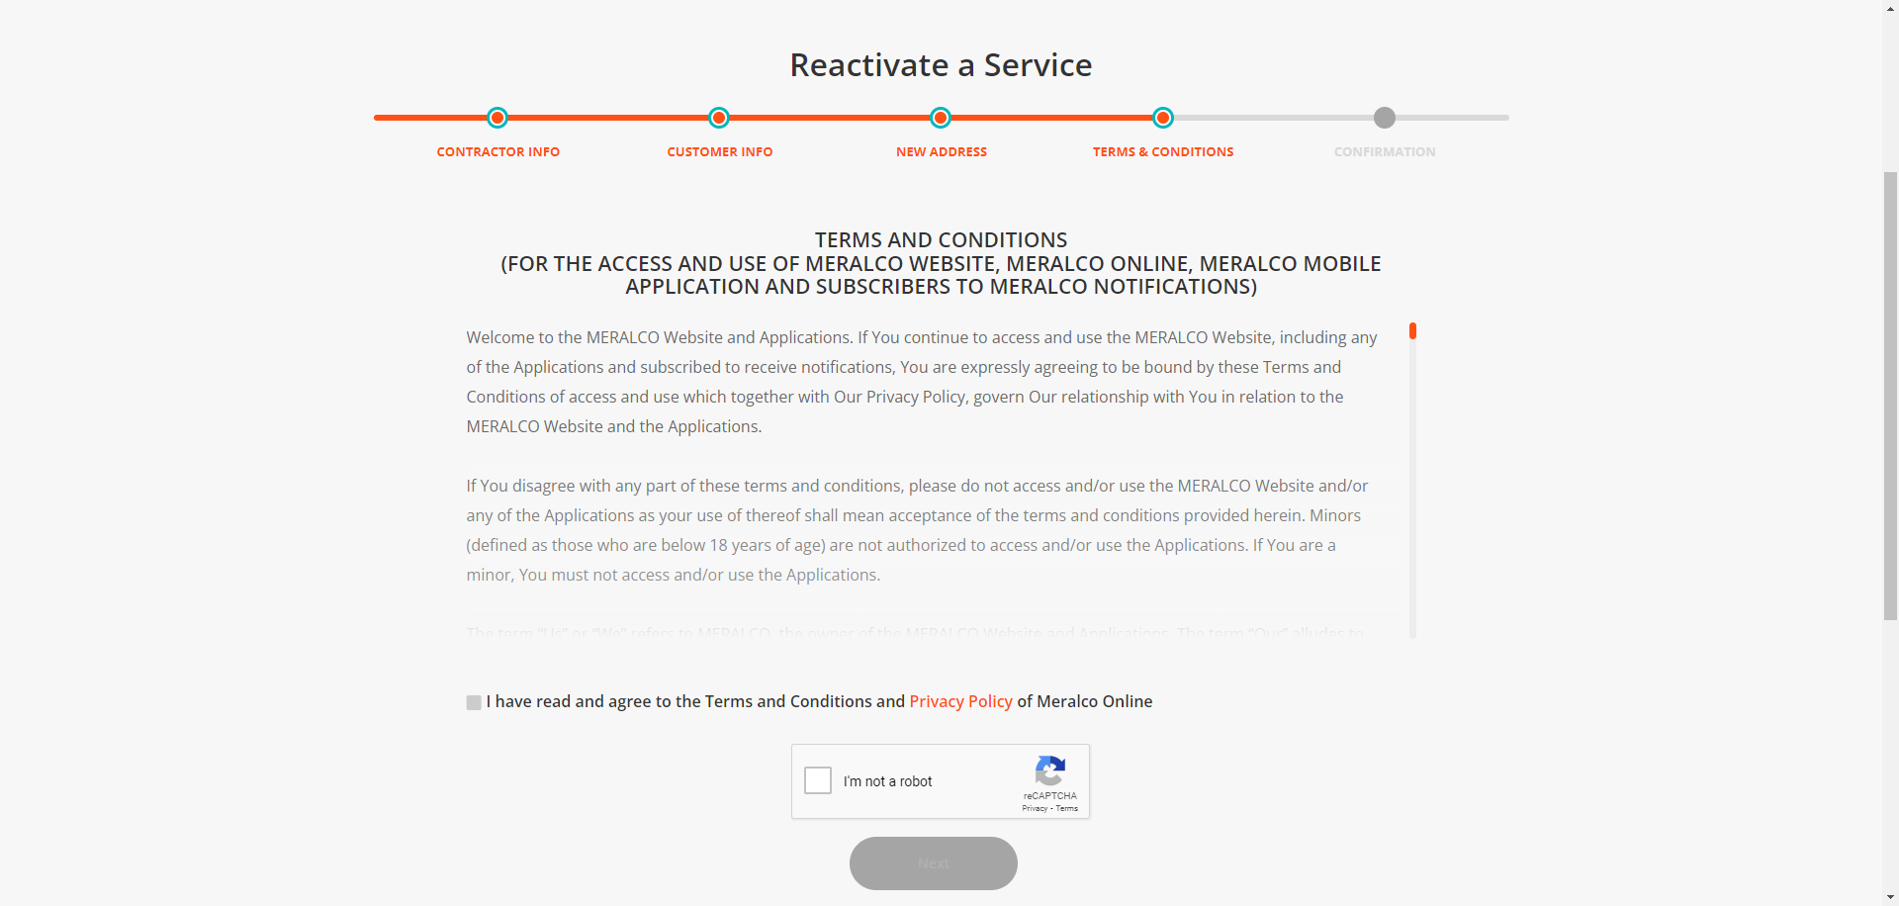

|  |
| --- |
| Step 10 - Populate the following: Notification indicator AMC indicator > Attach documents > Click Next |
| Fields should be populated; Terms and Conditions tab should be displayed |

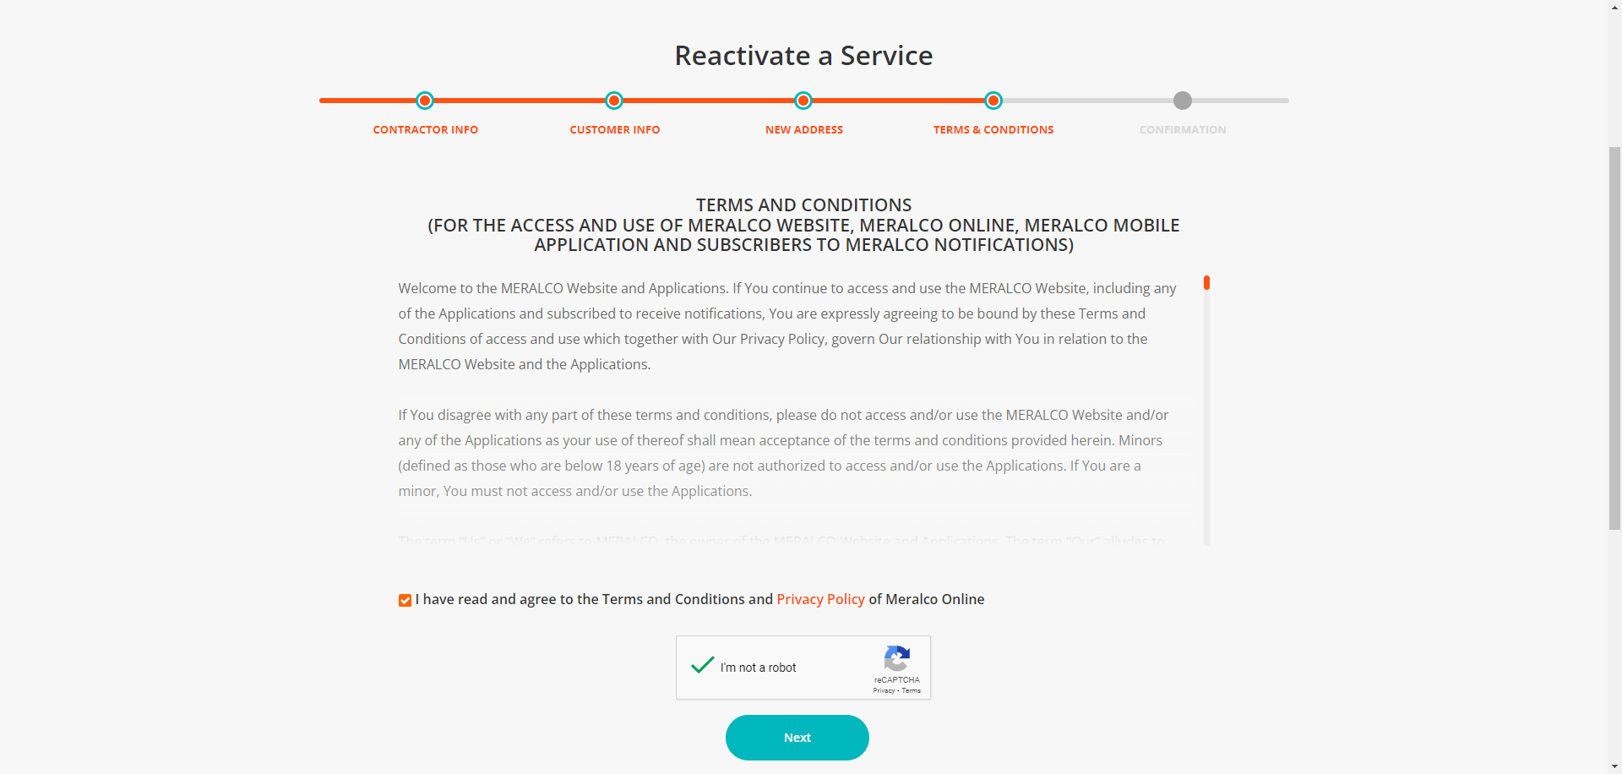

|  |
| --- |
| Step 11 - Tick on Terms & Conditions and Privacy Policy agreement |
| Submit button should be enabled |

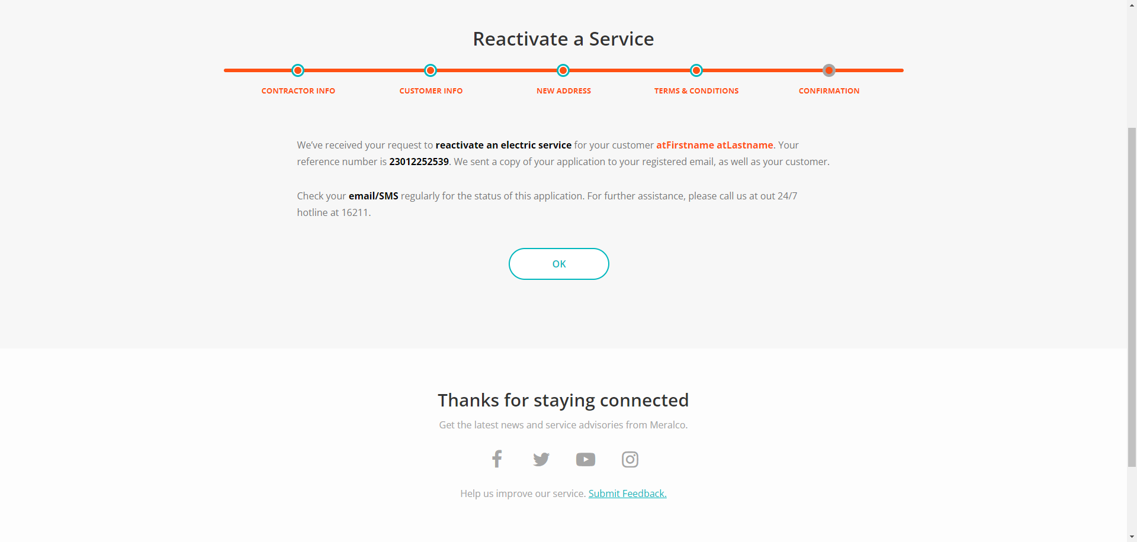



Passed